The shortcoming of Standard physical model

1. Computationally expensive, prone to overfitting
2. Incomplete knowledge of physical relationship and approximation in computing process would limit the accuracy of fitting

The short coming of ML model

1. Data expensive, while samples are usually sparse
2. Learning result is inconsistent with physical law
3. Not able to produce accurate prediction in the scenario that is not trained

Discover a way to combine these two approaches

Thus, Physical Guided Recurrent Neural Network (PGRNN) is proposed

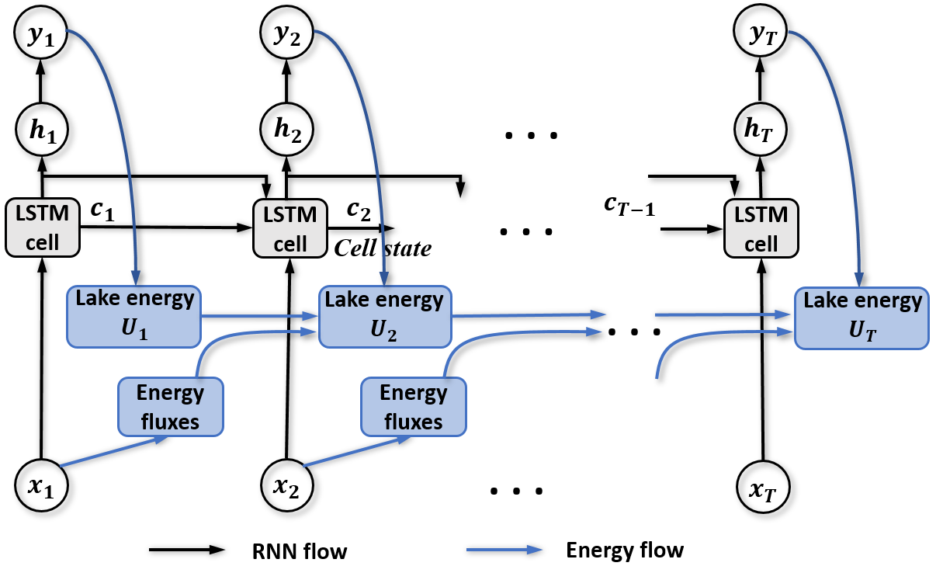

*Figure D. The flow of PGRNN model. (Jia et al., 2019)*

A RNN model with a single LSTM layer pretrained by the prediction data of a physical model – Great Lake Model (GLM) is proposed in the reference paper, as our baseline of the project.

In PGRNN model, the researchers applied the LSTM model for each depth separately and focused on the changing trend of internal energy and energy fluxes with time. However, the physical energy flux between different depth of the lake could not be taken into account in this model, causing the inability to make accurate prediction across depths. As shown in the Figure X from the reference below, where all the density obtained from the model is calculated based on their predicted temperature, the orange dotted line demonstrates the fact that, without training on the observed density data, the model could not produce a reliable prediction along the increasing depth, both for density and temperature.

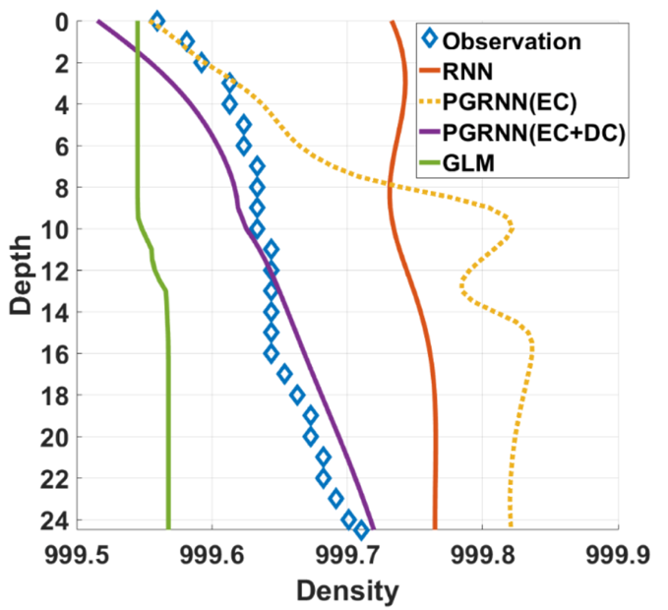

*Figure X. The obtained density values at different depths by different methods and ground-truth observations on May 20, 2002. (Jia et al., 2019)*

In order to improve the prediction quality across different depths in the lake, our project is proposing a spatial-temporal RNN as a substitute of simple LSTM model in the reference. Compared to the previous model, an extra bi-directional RNN layer is applied to represent the energy interaction between different depths in the lake, creating an improved Spatial Enhanced PGRNN.

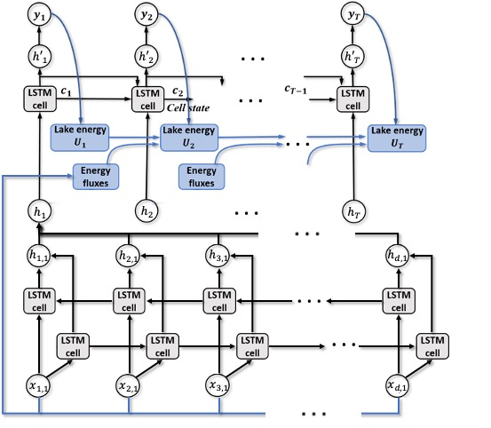

Figure Y. The flow of proposed Spatial Enhanced PGRNN

As a ML model dealing with spatial-temporal problems, the workflow of proposed Spatial Enhanced PGRNN is shown in Figure Y. At any given timestep, all the physics data at different depths is input into a bi-directional LSTM layer to learn the energy interaction between depths. Then the output of the bi-directional LSTM from different timestep would be reshaped and become the input of another LSTM layer representing the temporal aspect of energy flux.

Due to the slight difference between two LSTM layers for spatial and temporal factors, the sequence of two layers might potentially lead to difference learning performance. Typically, spatial-temporal ML models first process spatial aspect then temporal, while we are interested about whether an inverse sequence would produce a better prediction in this case. So, in this project, we will construct Spatial Enhanced PGRNN in both sequences, and make a comparison.

The aim of this project is to assess the learning performance of Spatial Enhanced PGRNN models by comparing the RMSE of their prediction and trend accuracy along the increasing depth in Lake Mendota, and chose the optimal model to propose as the recommended method for predicting temperature in the lake.